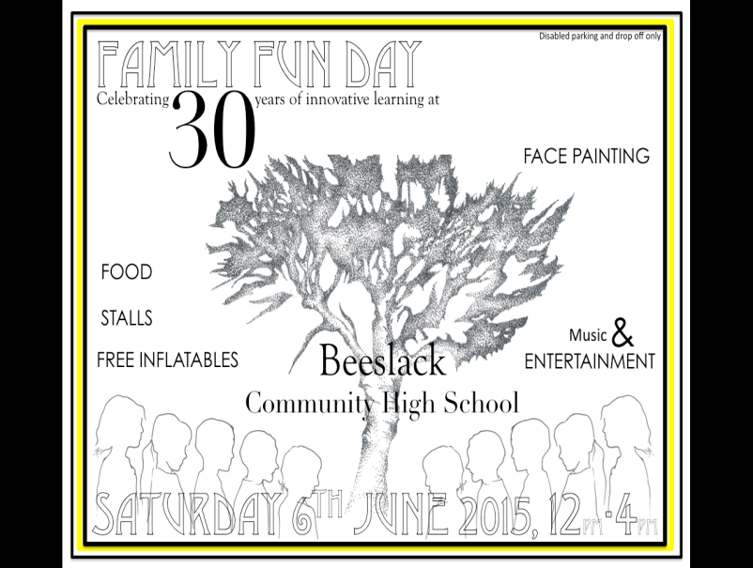
Beeslack Parent Council
Beeslack Community High School
Edinburgh Road
Penicuik
EH26 0QF
3rd May 2015

Hello,
We would like to invite all staff, pupils and parents at your school to our 30th Celebrations on Saturday 6th June 2015 12-4 pm@Beeslack Community High School. We have organised a giant slide, climbing wall, bungee football, and fun for all ages. We also have community groups running stalls and lots of music, with Jazz, a pipe band and a choir. There will be police and fire vehicles too. If there are any former pupils and staff among you, please forward any memories, photos on our Facebook page or copy and post them with your details to the school FAO Parent Council. Also, come along to the memory tent, on the day, and share your experiences of your time at Beeslack.
There will be parking for disabled only for safety reasons
We hope to see you there!
Wendy Irvine Chair Beeslack Parent Council

