

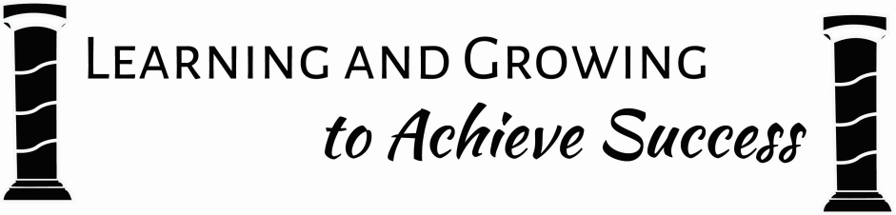

Primary 1 Newsletter

**HWB**

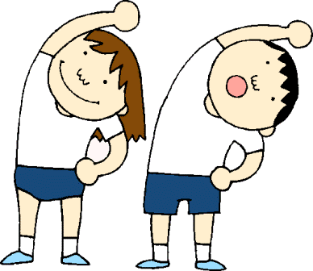This term we will be concentrating on learning new routines and understanding expectations for learning within our play-based environment. Once a week Miss Clark will be working with both classes on listening skills, Mrs Stentiford will be teaching music and we will be experiencing many skills in the gym hall every Monday afternoon.

If you haven’t already, please send in a gym kit, clearly labelled. Gym shoes will be used during the day if outdoor shoes are particularly muddy, wet, covered in grass or snow. Children are out in all weathers, particularly at break times so it is always a good idea to send your child with a jacket. Your child is welcome to keep a set of spare wellies in school, particularly for the winter months.

**Literacy**

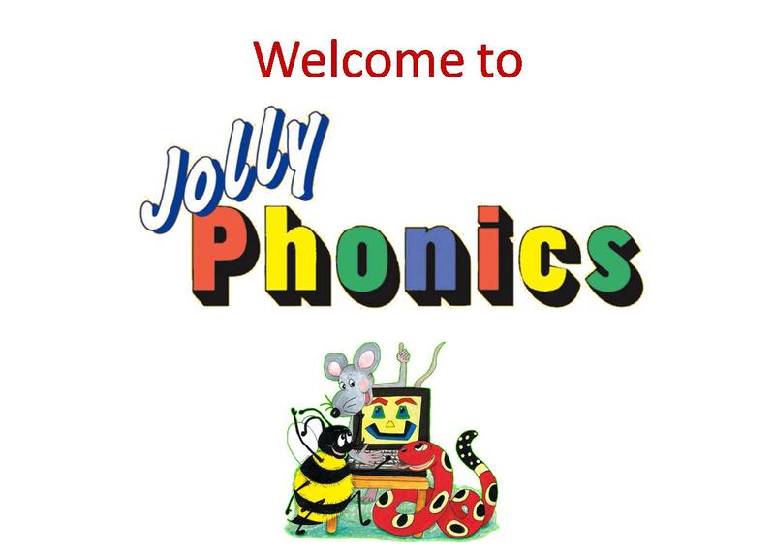Children are enjoying learning new sounds and ways to blend them together to make words. They can decide how they want to practise letter formation and are encouraged in class to use a variety of activities. Some children enjoy practising on a whiteboard while others prefer a hands-on approach using, for example, playdoh and sensory trays. Adults regularly work with groups of children to check their understanding of the sounds learned and ability to blend.

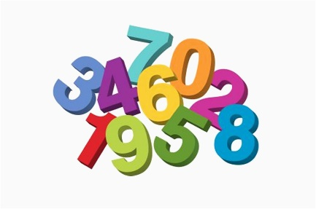

**Numeracy and Maths**

We will be focusing on Number Word Sequences and Number Structures at an appropriate level for your child. We will be learning finger patterns, dot and ten frame patterns and using dice and dominoes for instant recognition of numbers. We will develop our knowledge of number recognition, sequencing, counting forwards and backwards, working out one more / less and matching numerals to objects. We plan to look at patterns in our environment and create our own patterns using various play opportunities.

**Learning at home**

New sounds will be put in book bags on a Monday. After learning 6 sounds we will spend a week revising and consolidating sounds known so far with an emphasis on putting sounds together to read words. Please use the sound cards to build words with your child at home. Some ideas about how to help your child with numeracy will be sent home when appropriate.

**Parent Council Rep**

It was agreed at the last parent council meeting there would be a representative for each class. The representative for P1H is Holly Gibb and for P1B is Leila El-Helali. If you have any issues or suggestions that you want brought up and discussed at future meetings please contact either of these two people.

**Twitter**

You can keep up with what is going on in Primary 1 by following us on Twitter:

Ms Herd - @msaherd

Miss Brodie - @MissBrodie2

Roslin - @RoslinPS

Please don’t hesitate to ask any questions if you are unsure about anything. We look forward to working with you and your child throughout their time in P1.

Homework

Children will be given homework each week to consolidate learning in class. Initially new books will be sent home to read together on a Monday and Wednesday. Sounds should be continually revised at home and word building and blending can be encouraged.

Some ideas about how to help your child with numeracy will be sent home when appropriate.

Cross-curricular Learning

Our play based learning environment will feature autumn and farm activities so if you can donate conkers / acorns, farm vehicles or animals for us to play with, that would be much appreciated.

Later in the term we will look at changing seasons and our play base activities will reflect current class interest.

Homework

Children will be given homework each week to consolidate learning in class. Initially new books will be sent home to read together on a Monday and Wednesday. Sounds should be continually revised at home and word building and blending can be encouraged.

Some ideas about how to help your child with numeracy will be sent home when appropriate.

Cross-curricular Learning

Our play based learning environment will feature autumn and farm activities so if you can donate conkers / acorns, farm vehicles or animals for us to play with, that would be much appreciated.

Later in the term we will look at changing seasons and our play base activities will reflect current class interest.

Please ensure that all items of clothing are labelled as it saves valuable class time and ensures items are returned quickly. You may wish to check our P1 window before 8.50 or after 3.15 for further current class information. Please don’t hesitate to ask any questions if you are unsure about anything. I look forward to working with you and your child throughout their time in P1.

Alison Herd

Cross-curricular Learning

Our play based learning environment will feature autumn and farm activities so if you can donate conkers / acorns, farm vehicles or animals for us to play with, that would be much appreciated.

Later in the term we will look at changing seasons and our play base activities will reflect current class interest.

Homework

Children will be given homework each week to consolidate learning in class. Initially new books will be sent home to read together on a Monday and Wednesday. Sounds should be continually revised at home and word building and blending can be encouraged.

Some ideas about how to help your child with numeracy will be sent home when appropriate.