

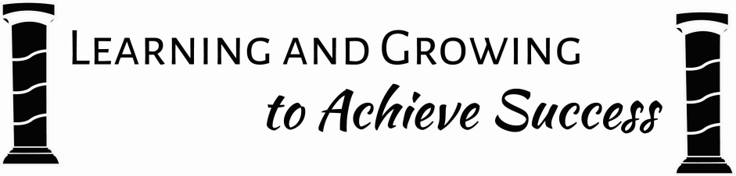

|  |
| --- |
| Primary 2 Term 1 Newsletter |

**Homework and Organisation**

The children are now receiving spelling homework in their new homework jotters and number homework sheets. This homework is given out on Mondays and is due on Fridays. Reading activities are detailed inside the front cover of the jotter. Please ensure your child has a PE kit in school each day and that items of clothing are labelled to help prevent mix ups! Many thanks for your support!

**Literacy**

This term we are linking letter names to their sounds, ordering letters and words alphabetically, and learning to use lowercase and uppercase letters appropriately. We are also working on our recall of common words, through a variety of daily games and activities. Our class book study is “Rainbow Fish” and this involves Learning Across the Curriculum.

P2 are practising their listening skills, with dedicated time for this where we have challenges to work on, individually or with a partner!

**Expressive Arts**

This term we are developing our drawing skills, working on careful observation, editing our work and listening to feedback to improve. The children are really enjoying their music lessons with our teaching specialist, Mrs Stentiford.

**Learning through Play**

In P2 children have daily opportunities to learn through play, making choices and following their own interests. These interests often develop into whole class work, for example, science units or social studies topics for the class. The children are encouraged to reflect on and talk about their learning during and after play.

Dear Parents/Carers,

Welcome to P2’s Autumn term newsletter. We have been enjoying getting used to our new classroom and the children have been thinking a lot about what helps us to learn.

We have created our class expectations, which will help us to get the most out of our P2 year. We also have as Parent Council Representative for P2, Mrs Claire Houston.

If you have any questions about your child’s learning, then please do not hesitate to contact me. I look forward to meeting with you all soon.

L. J. Lawson

**Health and Well-Being**

Our PE days are Tuesdays and Wednesdays. This term we are focusing on teamwork and cooperation.

We will be holding regular Circle Times where we will address social and emotional health and promote positive relationships.

We will also be looking at diversity and difference and considering how we can include and support everyone.

**Numeracy and Maths**

This term we are developing our number knowledge which includes: counting, using numerical language, ordering numbers, identifying patterns such as odd and even, and reading and writing numbers. You can support this at home by asking your child questions such as ‘What is 5 less than 12?’, ‘Which is bigger - 17 or 15?’ or ‘Is 19 an odd or even number?’ We are also learning about 2D and

3D shapes. Later this term we will be learning about money, including recognising coins and solving ‘real life’ problems.

**Wider Achievements**

If your child has accomplished any new achievements outside school please encourage them to let us know! We are starting a new class book where we will collect photographs and information about things we are learning at home. These achievements are also often shared at assembly with Mrs Wilson.